API data displayed on the page:
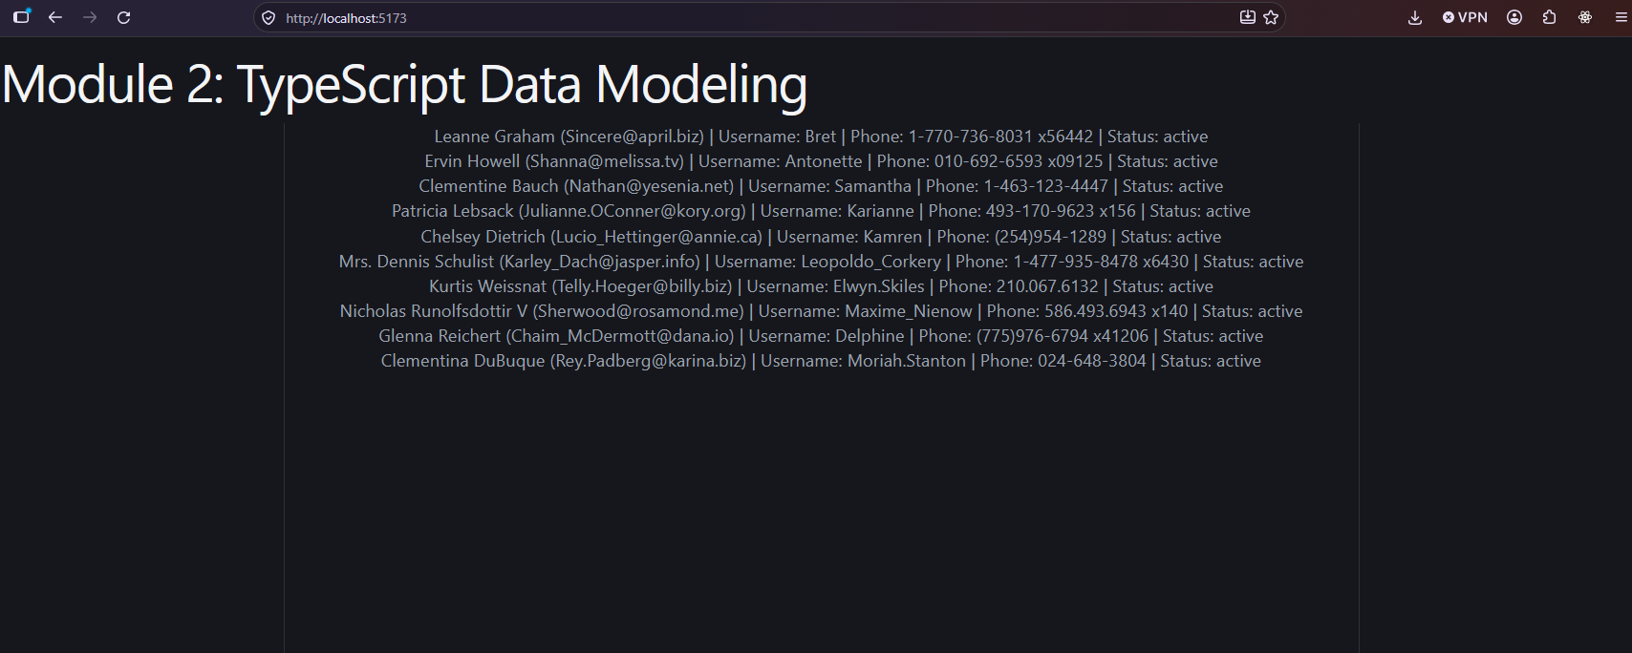
Completed Application: API Data and TypeScript Features:
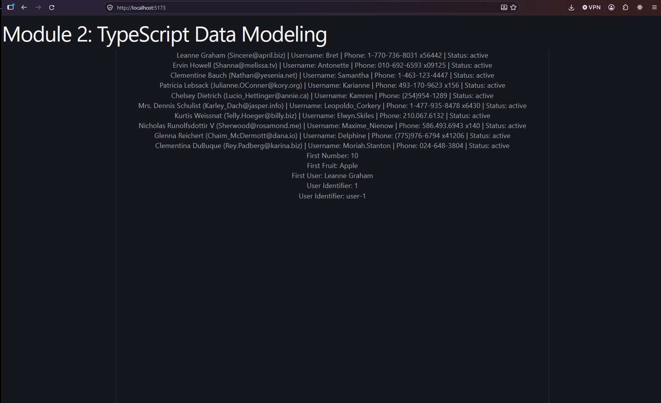
Running Application and Browser Console (No Errors)
